SMART TRAFFIC MANAGEMENT SYSTEM

The objectives of a traffic management system:

1. Reduce Traffic Congestion: Implement solutions to alleviate traffic congestion and improve the flow of vehicles on roads.
2. Enhance Safety: Improve road safety by reducing accidents and implementing measures to protect pedestrians and cyclists.
3. Efficient Resource Allocation: Optimize the allocation of resources such as traffic signals, signage, and law enforcement personnel.
4. Real-time Monitoring: Develop a system for real-time monitoring of traffic conditions and incidents.
5. Data Collection and Analysis: Collect and analyze traffic data to make informed decisions for future improvements.
6. Environmental Impact: Consider the environmental impact of traffic management and seek ways to reduce emissions and fuel consumption.
7. Public Awareness: Educate the public about traffic rules and encourage responsible behavior.
8. Integration of Technology: Incorporate modern technology, such as smart traffic lights, sensors, and communication systems, to improve traffic management.
9. Emergency Response: Ensure the system can support emergency services in case of accidents or other incidents.
10. Stakeholder Engagement: Involve key stakeholders, such as local government, transportation agencies, and the public, in the planning and implementation of the system.

These objectives aim to create a more efficient and safer transportation system while reducing the negative impact of traffic on the environment and the quality of life for residents.

Setting up IoT sensors for a traffic management system involves specialized sensors and considerations. Here’s a high-level overview of the steps:

1. Select Appropriate IoT Traffic Sensors:

Choose sensors designed for traffic management, such as traffic flow sensors, vehicle presence detectors, and environmental sensors (e.g., for air quality monitoring).

1. Communication Protocol:

Determine the communication protocol, often a combination of wireless and wired options, that best suits your traffic management system, considering factors like range and data transfer rate.

1. Hardware and Infrastructure:

Procure the necessary hardware, including sensors, microcontrollers, traffic signal controllers, and any infrastructure required for sensor placement, like traffic signal poles or roadside cabinets.

1. Software Development:

Develop or configure the software for sensors and data communication. This software should handle data collection, processing, and transmission.

1. Data Management:

Implement a data management system capable of handling large volumes of real-time traffic data. This may involve cloud-based platforms or local servers.

1. Sensor Placement:

Install sensors at key locations such as intersections, highways, or congested areas. Ensure that they are securely mounted and calibrated to capture accurate data.

1. Power Supply:

Ensure a reliable power supply for the sensors. Some IoT traffic sensors can be solar-powered, while others might require access to the electrical grid.

1. Security Measures:

Implement robust security measures to protect sensor data and the communication network from cyber threats and unauthorized access.

1. Data Analysis and Visualization:

Set up data analysis and visualization tools to process and present traffic data in a user-friendly format for real-time monitoring and decision-making.

1. Integration with Traffic Management Systems:

Integrate IoT sensor data with existing traffic management systems, including traffic signal control systems, dynamic message signs, and adaptive traffic control systems.

1. Maintenance and Monitoring:

Develop a maintenance plan to regularly monitor and maintain the sensors, ensuring they continue to function accurately. This may include routine sensor calibration and software updates.

1. Scalability:

Consider how to scale the sensor network to cover more areas or expand capabilities as traffic management needs evolve.

1. Compliance:

Ensure that your traffic management IoT setup adheres to relevant regulations and standards, especially when collecting sensitive traffic data.

1. User Interface:

Create a user interface or dashboard for traffic management personnel to access and interact with the collected traffic data.

1. Emergency Response Integration:

Integrate with emergency response services to provide data on accidents or incidents in real-time.

Customize the setup to align with the specific goals of your traffic management project, whether it’s focused on reducing congestion, improving safety, or enhancing traffic flow efficiency.

Developing a mobile app for a traffic management system involves several key steps and considerations:

1. Define Objectives and Features:

Determine the primary goals of the mobile app, such as real-time traffic updates, navigation, incident reporting, or integration with traffic sensors. Identify the essential features and functionalities.

1. Platform Selection:

Decide whether you want to develop the app for Android, iOS, or both platforms. This choice will affect the development tools and languages used.

1. User Interface (UI) Design:

Create a user-friendly and intuitive UI design that makes it easy for users to access and interact with traffic-related information. Consider the principles of good UX design.

1. Data Sources and APIs:

Integrate with data sources and APIs that provide traffic data, such as real-time traffic conditions, accident reports, and navigation information.

1. GPS and Mapping:

Utilize GPS and mapping services to provide users with accurate location-based information, including traffic routing and real-time updates.

1. Traffic Data Processing:

Implement algorithms to process traffic data, analyze it, and provide users with relevant information like route suggestions, estimated arrival times, and traffic alerts.

1. User Registration and Profiles:

Create user registration and profile management features if needed, allowing users to personalize their experience and receive relevant notifications.

1. Real-time Updates:

Implement features for real-time traffic updates and alerts, which can include traffic congestion, road closures, accidents, and detour recommendations.

1. Navigation and Routing:

Offer navigation and routing capabilities, enabling users to plan their routes and receive turn-by-turn directions to avoid traffic congestion.

1. Incident Reporting:

Allow users to report traffic incidents or issues, such as accidents, road hazards, or traffic violations, and provide a mechanism for authorities to respond.

1. Notifications and Alerts:

Implement push notifications to inform users of important updates and incidents affecting their routes.

1. Emergency Services Integration:

Enable integration with emergency services to provide users with emergency contact information and assist in crisis situations.

1. User Feedback:

Collect user feedback to continuously improve the app’s features and performance.

1. Security and Privacy:

Implement security measures to protect user data and privacy, especially if the app collects personal information or location data.

1. Testing and Quality Assurance:

Thoroughly test the app for functionality, performance, and usability. Conduct beta testing to gather user feedback and make necessary improvements.

1. Deployment and Distribution:

Publish the app on app stores like Google Play Store and Apple App Store. Ensure it meets the respective platform’s guidelines and requirements.

1. Maintenance and Updates:

Provide ongoing maintenance, bug fixes, and updates to keep the app running smoothly and to address user feedback and changing traffic conditions.

1. User Support:

Offer customer support and help resources to assist users with any issues or inquiries related to the app.

Developing a traffic management system mobile app requires a multi-disciplinary team of developers, designers, data scientists, and domain experts to ensure the app’s effectiveness and usability.

Here are some steps and considerations for Raspberry Pi integration:

1. Define Integration Goals:

Clearly outline the objectives and tasks you want the Raspberry Pi to perform within your traffic management system. This could include data collection, control of traffic lights, or processing sensor data.

1. Select Raspberry Pi Model:

Choose the appropriate Raspberry Pi model based on your requirements, considering factors such as processing power, connectivity options, and form factor.

1. Sensors and Peripherals:

Determine the necessary sensors and peripherals to connect to the Raspberry Pi. This might include traffic flow sensors, cameras, GPS modules, or communication modules.

1. Software Development:

Develop or configure software for the Raspberry Pi to interface with sensors, process data, and communicate with other system components. You can use Python, C/C++, or other languages depending on your needs.

1. Connectivity:

Ensure the Raspberry Pi has access to the necessary network connectivity, whether via Wi-Fi, Ethernet, or cellular connections, to transmit and receive data in real-time.

1. Power Supply:

Plan for a stable power supply for the Raspberry Pi, especially if it will be installed in a remote location. Options include batteries, solar panels, or direct electrical connections.

1. Data Processing:

Implement algorithms for data processing and analysis, such as traffic flow calculations, incident detection, or adaptive traffic signal control.

1. Data Transmission:

Set up methods to transmit processed data to other components of the traffic management system, such as a central server, a traffic control center, or other devices.

1. Real-time Monitoring:

Develop a user interface or dashboard for real-time monitoring and control of the Raspberry Pi and its connected sensors and peripherals.

1. Security Measures:

Implement security measures to protect the Raspberry Pi from unauthorized access and ensure the integrity of the data it processes.

1. Integration with Traffic Management Systems:

Ensure the Raspberry Pi can seamlessly integrate with existing traffic management systems, including traffic signal controllers and central traffic management software.

1. Testing and Validation:

Rigorously test the Raspberry Pi integration, including sensor accuracy, data processing, and communication reliability. Address any issues that arise during testing.

1. Maintenance and Monitoring:

Develop a maintenance plan for the Raspberry Pi, including remote monitoring capabilities and proactive measures to address hardware or software failures.

1. Scalability:

Consider how to scale the use of Raspberry Pi devices as needed to cover additional locations or expand the functionality of your traffic management system.

1. Compliance:

Ensure that your Raspberry Pi-based system complies with relevant regulations and standards for traffic management and data collection.

1. User Support:

Provide support and documentation for those responsible for maintaining and troubleshooting the Raspberry Pi-based system.

Raspberry Pi integration can add flexibility and affordability to a traffic management system, but it requires careful planning and development to ensure it meets your specific traffic management objectives.

Implementing a complete traffic management system involves complex software and hardware components. Below, I’ll provide a simplified example in Python to demonstrate how you can control traffic signals using a Raspberry Pi and GPIO (General Purpose Input/Output) pins. Please note that this is a basic illustration, and a real-world traffic management system would be significantly more complex.

1. Hardware Setup:

- Connect the Raspberry Pi to the traffic signal hardware via GPIO pins.

- Ensure that you have the necessary hardware, such as LEDs or relays, to simulate traffic signals.

2. Python Code:

Here’s a basic Python script that simulates traffic lights at an intersection with north-south and east-west directions:

```python

Import RPi.GPIO as GPIO

Import time

# GPIO pins for the traffic lights

North_south_green = 17

North_south_yellow = 18

North_south_red = 27

East_west_green = 22

East_west_yellow = 23

East_west_red = 24

# Initialize GPIO settings

GPIO.setmode(GPIO.BCM)

GPIO.setup(north_south_green, GPIO.OUT)

GPIO.setup(north_south_yellow, GPIO.OUT)

GPIO.setup(north_south_red, GPIO.OUT)

GPIO.setup(east_west_green, GPIO.OUT)

GPIO.setup(east_west_yellow, GPIO.OUT)

GPIO.setup(east_west_red, GPIO.OUT)

Try:

While True:

# Set North-South green, East-West red

GPIO.output(north_south_green, GPIO.HIGH)

GPIO.output(north_south_red, GPIO.LOW)

GPIO.output(east_west_green, GPIO.LOW)

GPIO.output(east_west_red, GPIO.HIGH)

Time.sleep(5) # Keep this state for 5 seconds

# Set North-South yellow

GPIO.output(north_south_green, GPIO.LOW)

GPIO.output(north_south_yellow, GPIO.HIGH)

Time.sleep(2) # Keep this state for 2 seconds

# Set North-South red, East-West green

GPIO.output(north_south_yellow, GPIO.LOW)

GPIO.output(north_south_red, GPIO.HIGH)

GPIO.output(east_west_green, GPIO.HIGH)

GPIO.output(east_west_red, GPIO.LOW)

Time.sleep(5) # Keep this state for 5 seconds

# Set East-West yellow

GPIO.output(east_west_green, GPIO.LOW)

GPIO.output(east_west_yellow, GPIO.HIGH)

Time.sleep(2) # Keep this state for 2 seconds

Except KeyboardInterrupt:

Pass

Finally:

# Cleanup and reset GPIO settings

GPIO.cleanup()

```

3. Execution:

- Copy this code to a Python file (e.g., `traffic_light.py`).

- Run the script on your Raspberry Pi.

This code example simulates a basic traffic signal pattern. In a real-world application, you would incorporate sensor data, communication with a central traffic management system, and more complex control logic based on real traffic conditions. This example serves as a starting point for understanding how traffic signal control can be implemented using a Raspberry Pi.

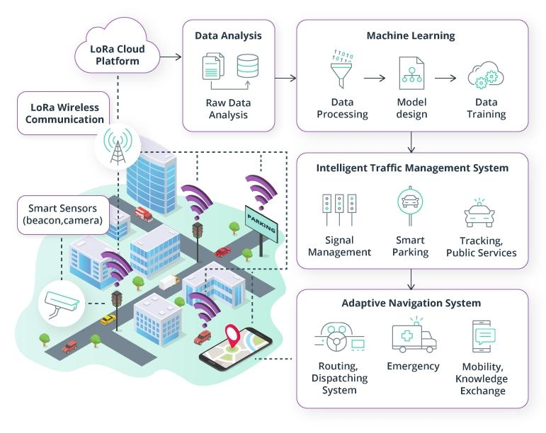

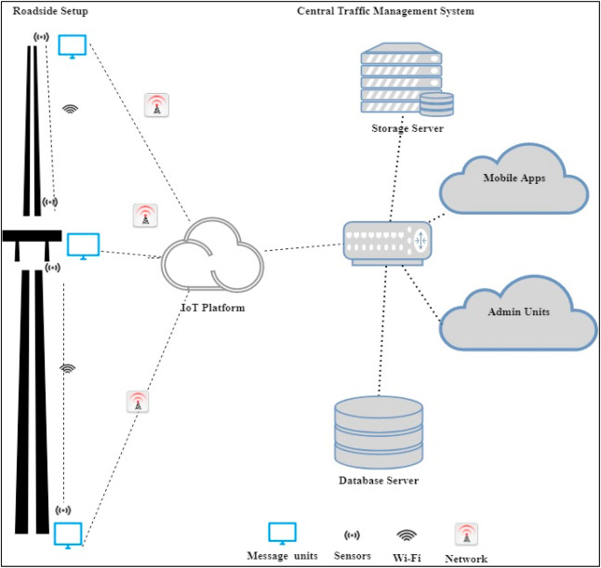

Creating schematics for a traffic management system involves multiple components and can be quite complex. Below, I’ll outline a simplified diagram to help you understand the basic structure of such a system. Keep in mind that a real traffic management system would involve more intricate details, sensors, and control mechanisms.

Traffic Management System Schematic Overview

1. Sensors:

- Traffic Flow Sensors

- Vehicle Presence Detectors

- Environmental Sensors (e.g., air quality)

2. Traffic Signal Control:

- Traffic Signal Controllers

- Traffic Lights (LEDs)

- Traffic Signal Timing Logic

3. Communication Network:

- Wired (e.g., Ethernet)

- Wireless (e.g., Wi-Fi, Cellular)

4. Central Traffic Management System:

- Central Traffic Control Center

- Data Processing and Analysis

- Traffic Data Storage

5. User Interface:

- Web-Based Dashboard

- Mobile Apps

- Traffic Information Displays

6. Emergency Response Integration:

- Connectivity to Emergency Services (e.g., police, ambulance)

- Incident Management

7. Traffic Data Distribution:

- Traffic Data Broadcast to:

- Traffic Information Displays

- Mobile Apps

- Local Traffic Control Centers

Basic Traffic Signal Control Flow

Here’s a simplified representation of how traffic signal control operates within the system:

1. *Traffic Flow Sensors* monitor vehicle movement and send data to the *Central Traffic Management System*.
2. The *Central Traffic Management System* processes this data to identify traffic conditions, congestion, and incidents.
3. Based on the data analysis, the system calculates optimal traffic signal timing.
4. The *Traffic Signal Controllers* receive updated timing instructions from the central system.
5. *Traffic Lights* (LEDs) at intersections change their signals based on the new timing instructions, optimizing traffic flow.
6. Commuters receive real-time traffic information and route suggestions through *Mobile Apps* or *Traffic Information Displays*.
7. In the event of accidents or emergencies, the system can communicate with *Emergency Services* to coordinate responses and implement necessary traffic management changes.

Please note that this is a simplified representation. A real traffic management system may involve additional components like CCTV cameras for monitoring, adaptive traffic signal control, public transportation integration, and much more. The design and complexity of the system depend on the specific requirements of the location and the desired features of the traffic management system.

A real-time traffic monitoring system can greatly assist commuters in making optimal route decisions and improving traffic flow in the following ways:

1. Real-Time Traffic Updates:

Commuters receive up-to-the-minute information about traffic conditions, including congestion, accidents, road closures, and delays. This information helps them avoid unexpected traffic issues.

1. Dynamic Route Planning:

Commuters can use navigation apps or systems that provide dynamic route planning based on real-time traffic data. These systems offer alternative routes to avoid traffic jams and reach their destinations faster.

1. Time and Fuel Savings:

By choosing the most efficient routes, commuters can save time and reduce fuel consumption, contributing to cost savings and environmental benefits.

1. Reduced Stress and Frustration:

Access to real-time traffic information allows commuters to plan their journeys with less stress and frustration, knowing they won’t be caught in severe traffic congestion.

1. Improved Traffic Distribution:

As commuters are directed to less congested routes, traffic flow is more evenly distributed across road networks, reducing the strain on heavily congested areas and preventing gridlock.

1. Incident Management:

Real-time monitoring enables authorities to respond swiftly to accidents, road hazards, and emergencies. Traffic management systems can reroute traffic or dispatch emergency services as needed.

1. Traffic Signal Optimization:

Traffic management systems can adjust traffic signal timings based on real-time data, improving traffic flow at intersections. This helps reduce stop-and-go traffic, which can lead to fuel wastage and increased congestion.

1. Public Transportation Integration:

Commuters can access real-time data for public transportation options, such as bus and train schedules, allowing for seamless intermodal travel and reducing the number of cars on the road.

1. Economic Benefits:

Reduced travel time and more predictable journeys can boost productivity and reduce business costs associated with transportation.

1. Environmental Impact:

Efficient traffic flow and reduced congestion lead to lower emissions and air pollution. Commuters can also make greener choices when they know the real-time environmental impact of their routes.

1. Traffic Data Collection and Analysis:

Traffic management systems collect extensive data on traffic patterns and behavior. This data can be used to make informed decisions, plan road improvements, and enhance urban planning.

1. Safety Enhancements:

Real-time traffic monitoring can identify hazardous conditions and locations prone to accidents. This information can lead to safety improvements, such as improved signage and road design.

1. Adaptive Traffic Management:

Adaptive traffic control systems use real-time data to adjust traffic signals and lanes to respond to changing traffic conditions. This enhances the overall traffic flow.

In summary, a real-time traffic monitoring system empowers commuters with the information they need to make smarter route decisions, reduces traffic congestion, minimizes travel times, and contributes to a more efficient and environmentally friendly transportation system. It is a crucial component of modern urban planning and traffic management, benefiting both individual commuters and the community as a whole.